Algorithm for file updates in Python

Project description
In this project, I worked with a text file containing an allow list of IP addresses and removed any IP addresses that appeared in a separate remove list. I used Python to open the file, read its contents, convert the data into a list, and iterate through the remove list to update the allow list. After removing the unwanted IP addresses, I converted the list back into a string and wrote the updated information back to the file. This algorithm shows how Python can be used to manage file data efficiently and keep records up to date.

Open the file that contains the allow list
To open the file, I assigned the file name "allow_list.txt" to the variable import_file. Then I used a with statement and the open() function to open the file safely. The with statement ensures that the file is properly handled after the block finishes, and the variable file stores the open file while it is being used.
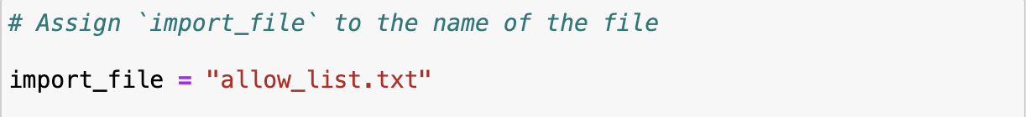

Read the file contents
To read the contents of the allow list file, I used the .read() method. This method converts the contents of the file into a string. I stored that string in the variable ip_addresses so I could work with the data later in the algorithm.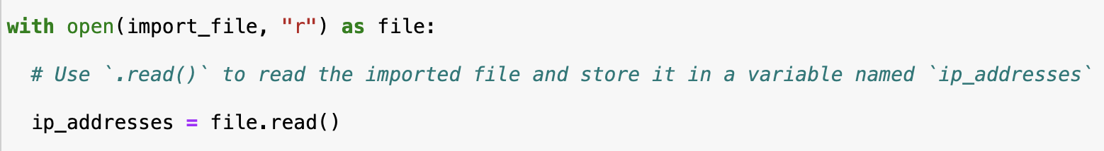

Convert the string into a list
After reading the file, I used the .split() method to convert the ip_addresses string into a list. This is necessary because individual IP addresses need to be separated so they can be removed one at a time. The .split() method breaks the string into separate elements and stores them in a list.
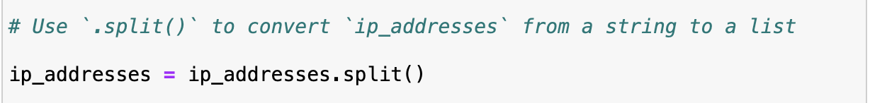

Iterate through the remove list
To check each IP address in the remove list, I created a for loop. The loop variable is element, and it goes through each item in remove_list one by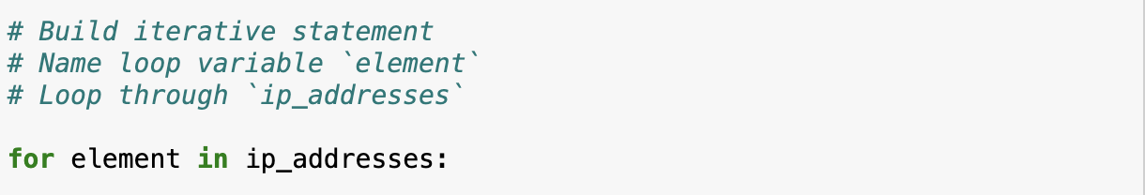

Remove IP addresses that are on the remove list
one. This allows the algorithm to compare each remove-list IP address with the IP addresses in the allow list.
Inside the loop, I used an if statement to check whether the current element is in the ip_addresses list. If it is, I used the .remove() method to delete it from the list. This works because there are no duplicates in the ip_addresses list, so each IP address appears only once.
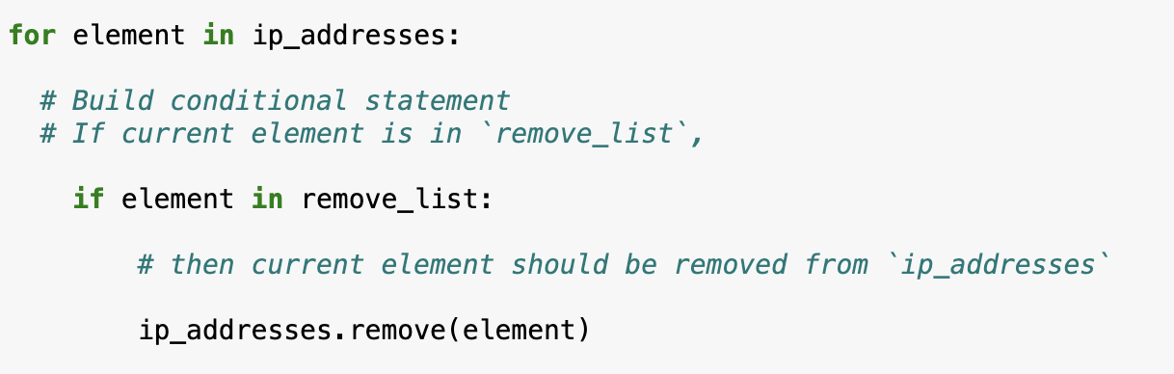

Update the file with the revised list of IP addresses
After removing the unwanted IP addresses, I used the .join() method to convert the list back into a string. I applied .join() to the string "\n" so each IP address appears on a separate line in the file. Then I used another with statement and the .write() method to overwrite the original file with the updated allow list.
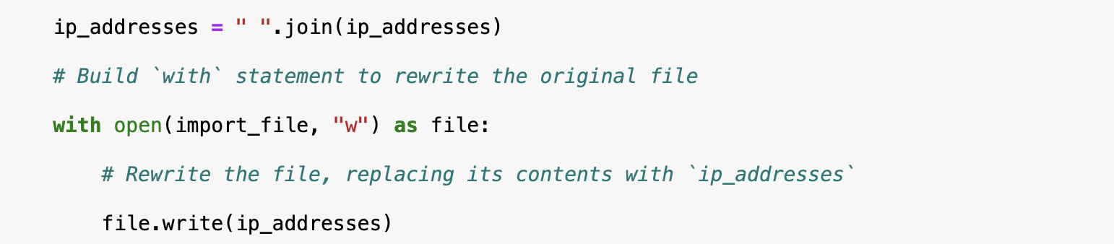

Summary
This algorithm updated an allow list file by removing IP addresses that also appeared in a remove list. First, the file was opened and read into a string using open() and .read(). Then the string was converted into a list with .split() so each IP address could be checked individually. A for loop and if statement were used to search the remove list and delete matching entries with .remove(). Finally, the updated list was converted back into a string with .join() and written back to the file with .write().

